**Monitors Web App**

| RVHS CT3 P2 2022 | |
| --- | --- |
|  |  |  |

**Task 4 [~ 1 hour 15 minutes]**



**Task 4.1**

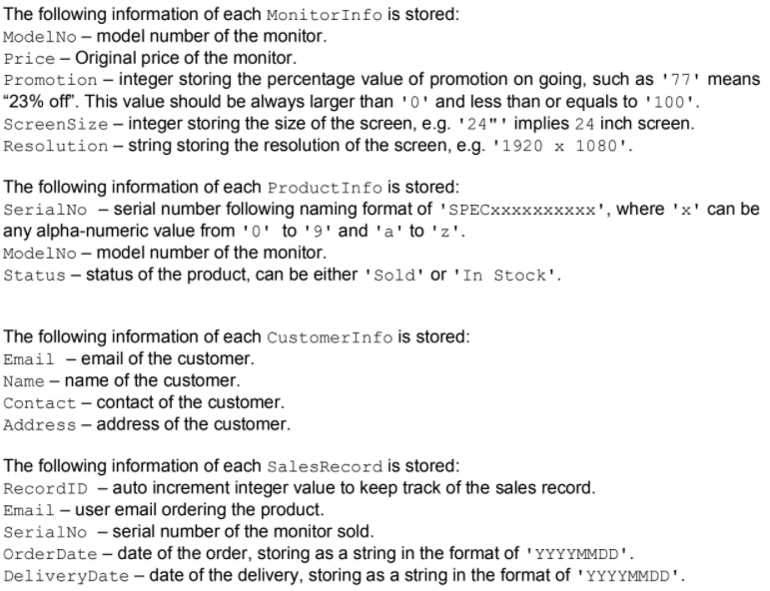



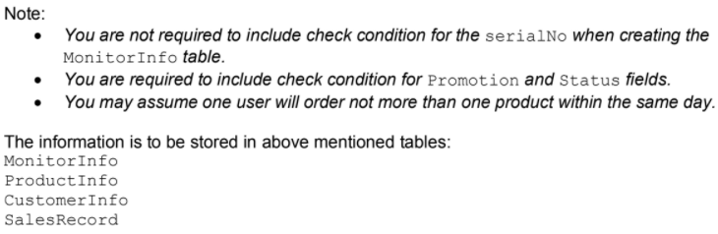

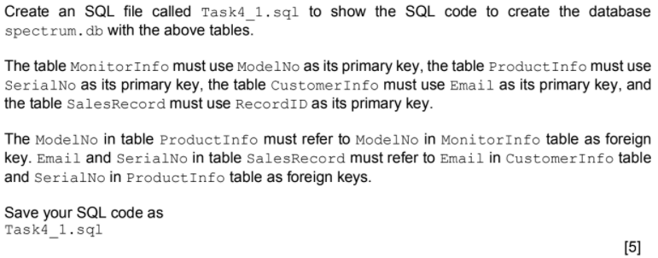

**Task 4.2**

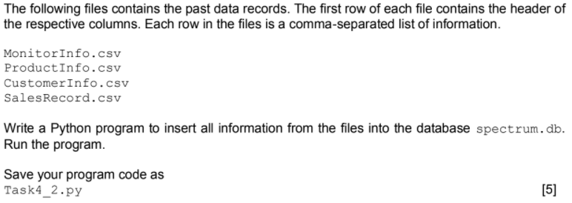

**Task 4.3**

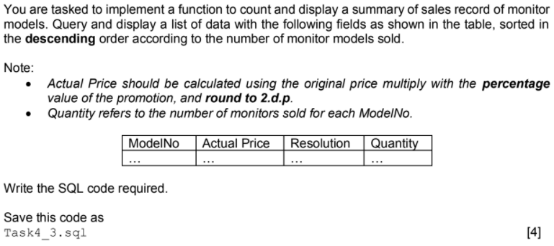

**Task 4.4**

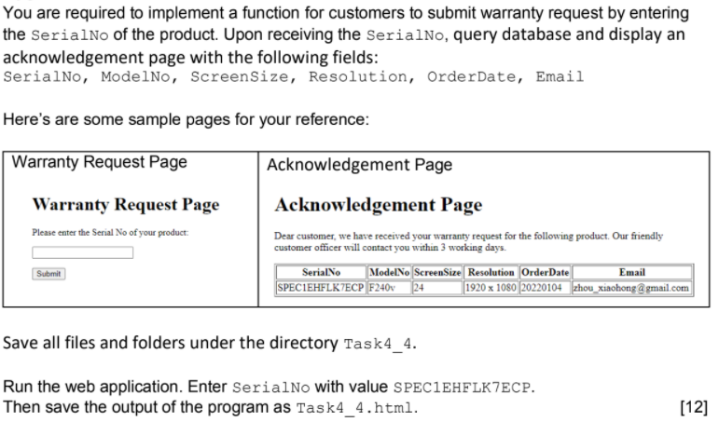

**Task 4.5**

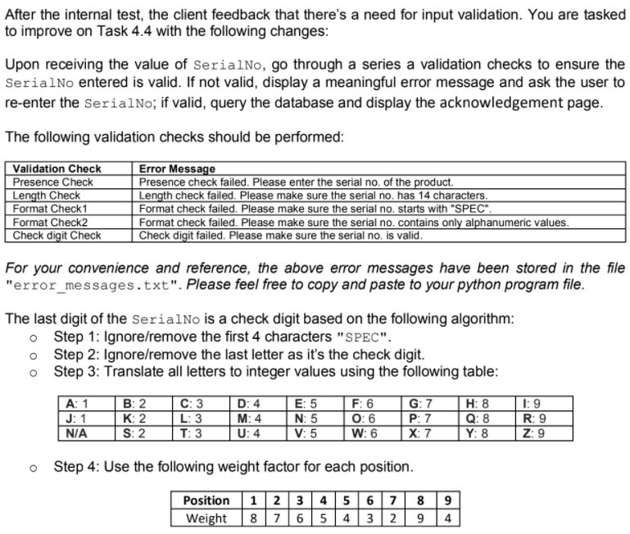

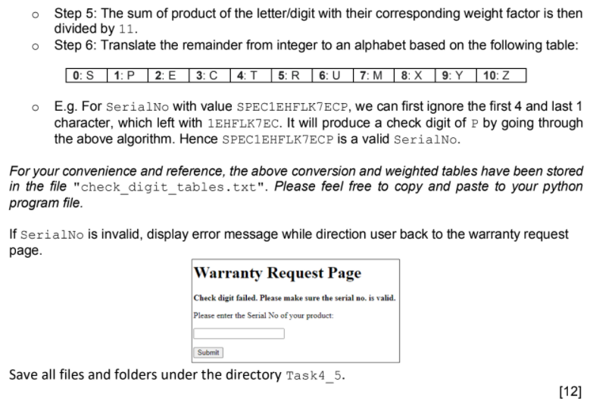

**Task 4.6**

